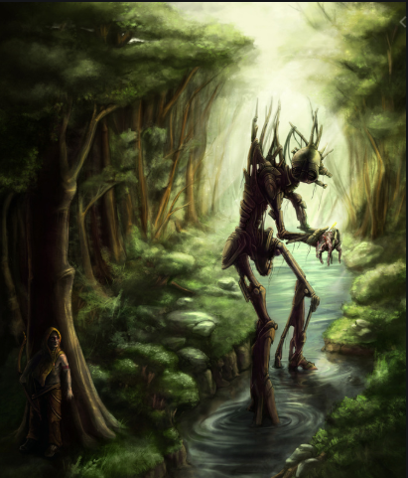

WALT: write a character description
Using the picture above, children are to write a detailed character description.
Things to include:
- Personification
- Similes
- Metaphors
- Adjectives
- Relative clauses
- Parenthesis
- Embedded clauses.

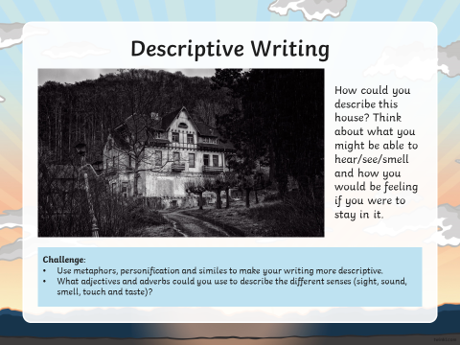

WALT: write a setting description

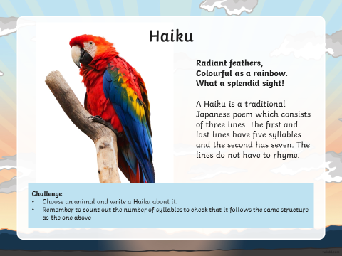

WALT: write a Haiku

