**Winwick Church of England Primary School**



Strategic Plan

2021 – 2024

**Foreword**

The School Governors and Senior Leadership Team are pleased to present our updated long-term Strategic Plan for Winwick CE Primary School. The document communicates our vision, values and ethos as well as our headline and strategic objectives for the next three years.

This will be reviewed on an annual basis by the school’s Governing Body and Senior Leadership team, with updates being delivered to parents and stakeholders termly.

We are extremely proud of the school’s values and of our achievements to date. We look forward to the next steps in our improvement journey which focuses on continuing with the excellent progress made in recent years and securing our vision to make Winwick CE a truly outstanding school.

Jackie Neal (Chair of Governors), Sue Dymond (Headteacher)

***For and on behalf of Winwick CE School Governing Body***

**Contact details**

Headteacher and Chair of Governors via email: [winwick_primary@sch.warrington.gov.uk](mailto:winwick_primary@sch.warrington.gov.uk)

# **Vision, Mission, Values & Ethos**

 “In God’s Love, aspire and achieve to be the best.”

**Our Core Christian Values**

Love – with the love of God and the love of one another.



Respect – to respect all things and the world we live in.

 Perseverance – to keep going and support each other in all things.

**Vision Tree**

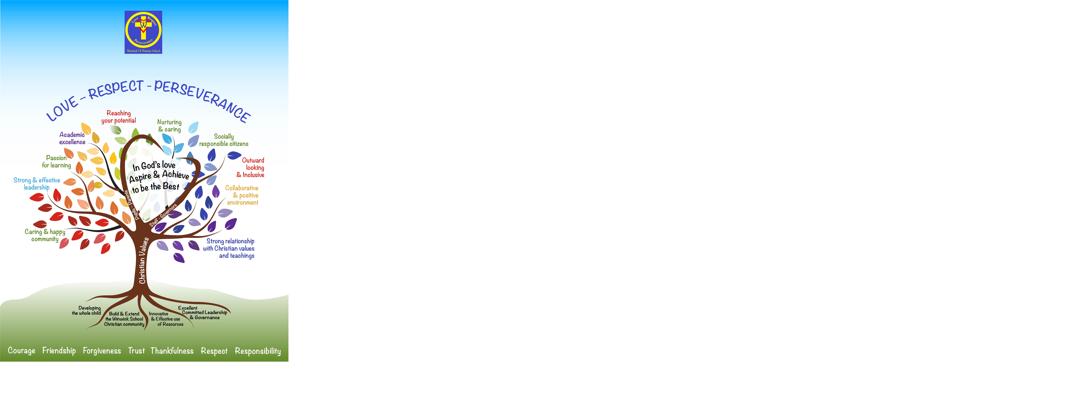

**Strategic Priorities for 2021-2024**

**A. Excellence for all; developing the whole child**

* Ensure the Christian teachings and ethos are at the heart of all that we do.
* Sustain and build on the passion for learning and teaching in the school, amongst pupils, parents and staff.
* Ensure that excellent progress and attainment are achieved within and across each year group providing the necessary support to ensure that every child reaches their full potential, carefully and safely.
* Provide opportunities to develop rounded individuals, enabling each child to grow up to become a socially responsible citizen in our world, and be respectful of difference.
* Create a motivating and fit for purpose environment to engage pupils, support and develop a fully committed staff team, whilst providing excellent and achievable opportunities for everyone’s development.

**2021-2022 The focus for Leaders and Governors will be:**

* Ensuring the wider curriculum in all areas is as robust as possible and that Governors have a thorough knowledge and understanding of the content and progression for each subject delivered.

**B. Continue to build and extend the Winwick Primary School community - encompassing pupils, parents, staff and wider church, local and global communities**

* Be an outward looking and inclusive school, seeking relationships with the community to support physical space limitations, provide enriching activities and opportunities to develop and progress the curriculum.

* To continue to be the school of choice - for children to attend, for staff to be employed and for governors to support and challenge in.

* Nurture and protect the SMSC (Spiritual, Moral, Social and Cultural) environment - encouraging links across all ages, collective worship and collaborative working in managing change to improve our school and its community.
* Support and protect pupil, parent, staff and governor health and wellbeing; fostering positive and collaborative relationships between the school body, pupils, staff and governors, as well as parents, volunteers, church, local community and wider school partnership links.

**2021-2022**

**The focus for Leaders and Governors will be:**

* Ensuring the wellbeing of all pupils, staff and other stakeholders is at the heart of all decision making.

**C. Provide effective and innovative use of resources**

* + Excellent financial planning to manage and monitor the school budget - maximising the use of resources and optimising a range of additional revenue opportunities.
  + Manage the school’s physical space in the most effective and efficient way to provide an excellent learning environment for our pupils; developing relationships within the community to support this and our external area plans.
  + Reduce the carbon footprint of the school year-on-year, ensuring the improvements made to the building and grounds always consider and utilise environmentally friendly options.

**2021-2022 The focus for Leaders and Governors will be:**

* Utilise the school site to ensure that the footprint of the site has maximum impact on pupil wellbeing, learning and community need, whilst respecting the environment.

1. **Provide excellent, committed leadership, governance and financial control**

* + Be proactive and responsive to changes and updates in government policy and funding - ensuring effective management and financial control of the challenges related to a single-form-entry school.
  + Maintain and promote high standards of strong, effective and committed leadership and governance; respecting and attracting highly skilled and motivated leadership talent.
  + Effectively utilise links with the Local Authority and Diocese to ensure leadership and governance is of the highest standard.

**2021-2022 The focus for Leaders and Governors will be:**

* Maintain the scrutiny of all financial decisions and ensure that the expertise within the leadership team is utilised effectively through external partnerships and agreements.