Year 1 Spelling Overview – Autumn 1
- This terms Spelling lists are based on the common exception works (CEWs) that children need to learn to read and spell in Year 1.
- Spellings will usually be tested on a FRIDAY and the spelling week will run from a FRIDAY to a FRIDAY
- You should spend time each week learning and practicing your spelling for that week.
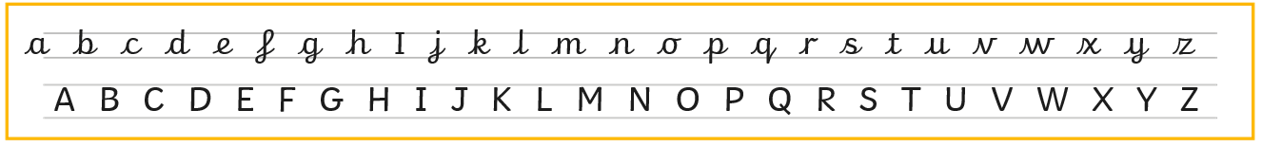
Below is our handwriting formation example that the children will be learning in school, it would be beneficial for the children to try to form these letters when practicing their spellings.
WEEK 1  Wk Beg: 8.9.25 | WEEK 2  Wk Beg: 15.9.25 | WEEK 3  Wk Beg: 22.9.25 | WEEK 4  Wk Beg: 28.9.25 | WEEK 5  Wk Beg: 6.10.25 | WEEK 6  Wk Beg: 13.10.25 | WEEK 7  Wk Beg: 20.10.25
Set 1 | Set 2 | Set 3 | Set 4 | Set 5 | Set 6 | Set 7
Y1 CEWs | Y1 CEWs | Y1 CEWs | Y1 CEWs | Y1 CEWs | Y1 CEWs
- the  - a  - do  - to  - today | - of  - said  - says  - are  - were | - was  - is  - his  - has  - I | - you  - your  - they  - be  - he | - me  - she  - we  - no  - go | - so  - by  - my  - here  - there | - where  - love  - come  - some  - one
TEST DATE:  12.9.25 | TEST DATE:  19.9.25 | TEST DATE:  26.9.25 | TEST DATE:  3.10.25 | TEST DATE:  10.10.25 | TEST DATE:  17.10.25 | TEST DATE:  24.10.25

