Year 1 Spelling Overview – Autumn 2
- This terms Spelling lists are based on the phonics sounds we will be revising this half term. There will also be one common exception word (CEW) spelling that children need to learn to read and spell in Year 1.
- Spellings will usually be tested on a FRIDAY and the spelling week will run from a FRIDAY to a FRIDAY
- You should spend time each week learning and practicing your spelling for that week.
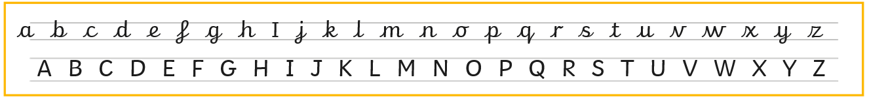
Below is our handwriting formation example that the children will be learning in school, it would be beneficial for the children to try to form these letters when practicing their spellings.
WEEK 1  Wk Beg: 03.11.25 | WEEK 2  Wk Beg: 10.11.25 | WEEK 3  Wk Beg: 17.11.25 | WEEK 4  Wk Beg: 24.11.25 | WEEK 5  Wk Beg: 01.12.25 | WEEK 6  Wk Beg: 08.12.25 | WEEK 7  Wk Beg: 15.12.25
Set 1 | Set 2 | Set 3 | Set 4 | Set 5 | Set 6 | Set 7
Focus sounds:  ai, ee, igh, oa | Focus sounds:  oo, oo, or, ar | Focus sounds:  ow, ur, ear, oi, air | Focus sounds:  er, bb, rr, tt, mm | Focus sounds:  Gg, dd, pp.ff | Focus:  Longer words | Focus:  Longer words
- paint  - sleep  - bright  - floats  - sailboat  - put | - zooming  - hooked  - sorts  - march  - target  - pull | - beard  - boiling  - curls  - flower  - funfair  - full | - boxer  - rabbit  - kitten  - carrot  - hammer  - and | - ladder  - bigger  - puppet  - toffee  - ribbon  - push | - sunset  - pocket  - carpet  - rooftop  - carpark  - was | - velevt  - chicken  - bedroom  - farmyard  - market  - you
TEST DATE:  07.11.25 | TEST DATE:  14.11.25 | TEST DATE:  21.11.25 | TEST DATE:  28.11.25 | TEST DATE:  05.12.25 | TEST DATE:  12.12.25 | TEST DATE:  19.12.25

