July 2020
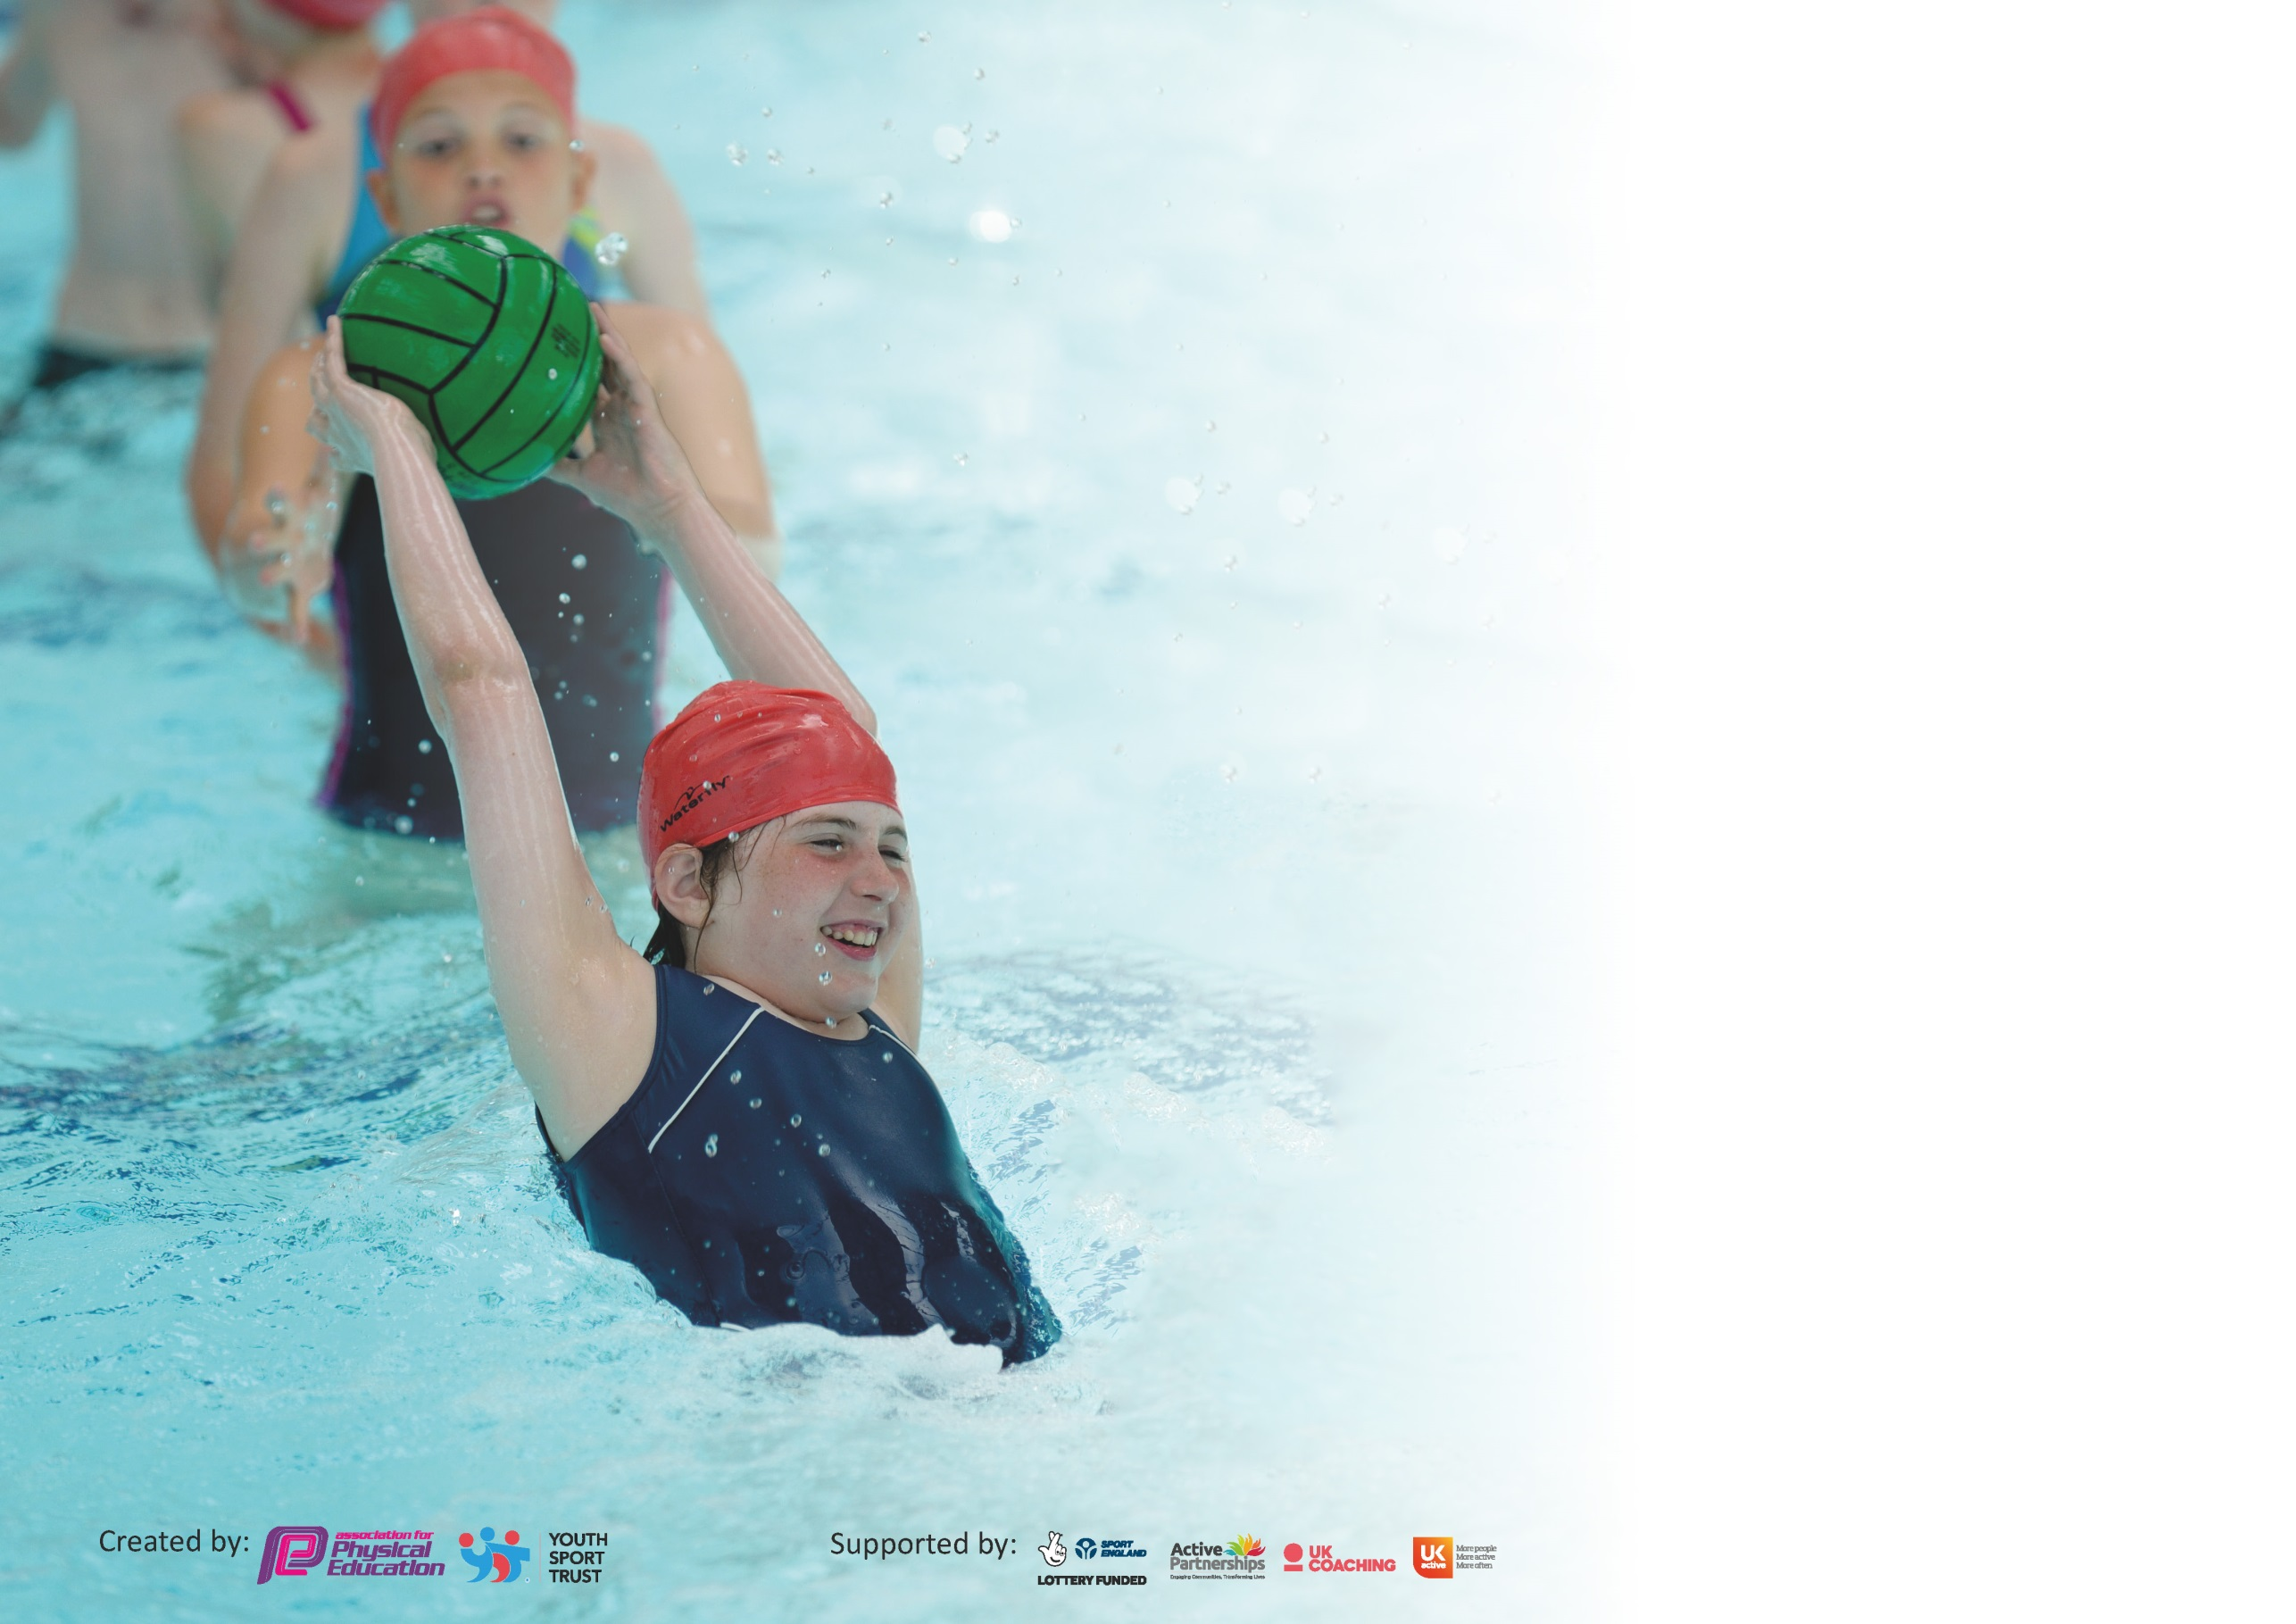

It is important that your grant is used effectively and based on school need. The Education Inspection Framework (Ofsted 2019 p64) makes clear there will be a focus on ‘whether leaders and those responsible for governors all understand their respective roles and perform these in a way that enhances the effectiveness of the school’.

Under the Quality of Education criteria (p41) inspectors consider the extent to which schools can articulate their curriculum (INTENT), construct their curriculum (IMPLEMENTATION) and demonstrate the outcomes which result (IMPACT).

To assist schools with common transferable language this template has been developed to utilise the same three headings which should make your plans easily transferable between working documents.

Schools must use the funding to make additional and sustainable improvements to the quality of Physical Education, School Sport and Physical Activity (PESSPA) they offer. This means that you should
use the Primary PE and Sport Premium to:

- Develop or add to the PESSPA activities that your school already offer
- Build capacity and capability within the school to ensure that improvements made now will benefit pupils joining the school in future years

Please visit gov.uk for the revised DfE guidance including the 5 key indicators across which schools should demonstrate an improvement. This document will help you to review your provision and to report your spend. DfE encourages schools to use this template as an effective way of meeting the reporting requirements of the Primary PE and Sport Premium.

We recommend you start by reflecting on the impact of current provision and reviewing the previous spend.

Schools are required to publish details of how they spend this funding as well as on the impact it has on pupils’ PE and sport participation and attainment by the end of the summer term or by 31st July 2020 at the latest.

We recommend regularly updating the table and publishing it on your website throughout the year. This evidences your ongoing self-evaluation of how you are using the funding to secure maximum, sustainable impact. Final copy must be posted on your website by the end of the academic year and no later than the 31st July 2020. To see an example of how to complete the table please click HERE.

Support for review and reflection - considering the 5 key indicators from DfE, what development needs are a priority for your setting and your pupils now and why? Use the space below to reflect on previous spend and key achievements and areas for development.

Key achievements to date until July 2020: | Areas for further improvement and baseline evidence of need:
The percentage increase of tournaments/competitions entered this year has continued to increase along with intra competitions.  The recognition of being awarded the Sports Gold Award 2018/19.  Continued to work towards Sports Gold Award 2019/2020 – Due to COVID - p  Continuation of the Playground leaders program. Fully implemented, training and change overs.  Continuation of Leadership skills with local college students-LLS  School used as a hub of sporting activities over the half term breaks, Offer made to neighbouring schools and the wider community-up to March 20  The development of sporting access during the pandemic-social distancing games, dance mixes or Joe Wicks’s sessions | To look at the data for our current Year 5 and 6 and to make swimming an opportunity, if any have not attained the standard for swimming and water safety.  Moving forward the development of a PE curriculum in line with the Government Policy. A recovery curriculum enabling children to still access PE activities. Developing both their physical and mental well-being, in this time of a pandemic.

Meeting national curriculum requirements for swimming and water safety.
What percentage of your current Year 6 cohort swim competently, confidently and proficiently over a distance of at least 25 metres?  N.B. Even though your pupils may swim in another year please report on their attainment on leaving  primary school at the end of the summer term 2020. | 100%
What percentage of your current Year 6 cohort use a range of strokes effectively [for example, front crawl, backstroke and breaststroke]? | 86%  Due to our swimming taking place in Summer Term and current circumstances the Y6 children who had still not attained this were unable to have the opportunity.
What percentage of your current Year 6 cohort perform safe self-rescue in different water-based situations? | 86%  Due to our swimming taking place in Summer Term and current circumstances the Y6 children who had still not attained this were unable to have the opportunity.
Schools can choose to use the Primary PE and Sport Premium to provide additional provision for swimming but this must be for activity over and above the national curriculum requirements. Have you used it in this way? | No

Action Plan and Budget Tracking
Capture your intended annual spend against the 5 key indicators. Clarify the success criteria and evidence of impact that you intend to measure to evaluate for pupils today and for the future.

Academic Year: 2019/20 | Total fund allocated: £17,890 | Date Updated:
Key indicator 1: The engagement of all pupils in regular physical activity – Chief Medical Officer guidelines recommend that primary school pupils undertake at least 30 minutes of physical activity a day in school |  |  |  | Percentage of total allocation:
 |  |  |  | %
Intent | Implementation |  | Impact
Your school focus should be clear what you want the pupils to know and be able to do and about  what they need to learn and to  consolidate through practice: | Make sure your actions to achieve are linked to your intentions: | Funding allocated: | Evidence of impact: what do pupils now know and what can they now do? What has changed? | Sustainability and suggested next steps:
The opportunity to attend lunchtime and after school club activities to fully the recommended 30 minutes a day. Extra play leaders from LLS (To support physical development for selected groupings).  Replacement of ‘Sports and Games equipment’ purchased for lunchtime club with MDA’s and Playground leaders(Year 5)  Breakfast club to encourage the children who attend to get involved in activities.  During home learning - provided the children with a broad range of activities to access from home. As well as encouraging them to send in any pictures and videos. | Introduction and clearance of LLS students (DBS checked and all relevant material read before engaging with children)-Working with highlighted groups. LLS students also shadowed the Sports coach during PE lessons- who highlighted groups of children to encourage to become engaged.  Equipment such as skipping ropes, balls, bats, chalks to be purchased. Work with MDA’s to develop a register system to record children who are/aren’t participating.  Identify a staff member to undertake activities.  Introduce activities in which all pupils can be involved (e.g. wake up and shake, Joe Wicks and Just Dance).  Introduce activities to the children through our website and encourage them to get involved with challenges from the staff.  Activities  Joe Wicks  Wake and Shake  Just Dance  Fitness challenge  Dance Challenge etc | £10,000  £300  Internal costings -school budget. | The inactive groupings of children will weekly be engaged in physical activities. A continuation of focus on the children previously identified from Y1 height and weight as well as encouraging the children identified from PE lessons that lack engagement in physical activity.  New equipment is being used regularly at lunchtimes. Children have enjoyed the opportunity to use, skipping ropes, balls and rackets so far this academic year.  MDA’s report a large increase in physical activity at lunchtimes due to enthusiasm for equipment.  95% of pupils that attend breakfast club participate in an activity whether its wake and shake or using the outside facilities.  Children sending in videos/photos of them engaging in physical activity at home and completing challenges from staff. | Using the height and weight information –Reception groupings –these children can be tracked throughout their Primary phase education.  Children offered a variety of activities using the pitch and MUGGA Area-football. Netball, dodge ball, trip trail etc. As well as intra competitions from LLS students and Y5 sports leaders taking place at playtime and lunchtime.  Continue to provide new and engaging sporting opportunities. Generate register system to gather data on numbers of children. Information used against of highlighted inactive children.  To increase the % of children who participate in activities during breakfast club.  To continue to encourage children to engage in physical activity in preparation to returning to school.
Key indicator 2: The profile of PESSPA being raised across the school as a tool for whole school improvement |  |  |  | Percentage of total allocation:
 |  |  |  | %
Intent | Implementation |  | Impact
Your school focus should be clear what you want the pupils to know and be able to do and about  what they need to learn and to  consolidate through practice: | Make sure your actions to achieve are linked to your intentions: | Funding allocated: | Evidence of impact: what do pupils now know and what can they now do? What has changed? | Sustainability and suggested next steps:
The children have been able to enjoy intra school competitions at lunchtime.  Leadership skills-playground leaders for activities in Key Stage 1  Leadership- House Captains to deliver activities in Key Stage 2  Celebrate children’s sporting successes with a weekly sports person award in celebration assembly. Individual classes as well as an overall sports person of the week.  PE display board to be updated weekly with winners, events competed in, calendar of clubs /activities for that term.  Development of a power point presentation of all the events covered over a half term. This will be an excellent celebration of events/achievements over the terms.  Sports for champions (postponed 31/03/2020 – COVID)  To have an Olympic medallist come into school and talk about their sport in an assembly and deliver a fitness session to the children.  Basketball/tennis coaches  Regular visits from coaches in the local community. | The playground leaders have had additional coaching and therefore the quality of the sessions-planning and delivery should improve.  There are certificates for each class.  Ensure system focuses on those children who are least active to encourage them to want to increase participation. This is still a going target. H and W information is used as a valuable source of identification. PE Coach to organise  The constant turnover of the events/certificates and activities have really inspired the children over the last academic year.  Through sports for champions invite a local Olympian into school to inspire the children in the build up to the Olympics (2020).  Marathon fundraiser – each year group run a set amount of a marathon increasing distance by year group.  These sessions signpost where the children can participate in leagues. Handing out and publishing events and opportunities to participate in these sports. | Wasp-Provision  £1860  £50  Administration costs  Time/ fundraiser | The children have had a good level of coaching so that they can see the importance of physical activity-using their leadership skills they can motivate, encourage the younger children to participate in organised activities.  The impact of the children receiving certificates each week as been extremely positive.  The impact has been the children’s interest and enthusiasm to follow the events on the board. Plus celebrating in the opportunities to represent the school.  COVID – 19  (Would have engaged in a fitness session with the athlete, completed a marathon as a school. Inspired the children to become more active and try new things.)  More children becoming actively involved in sporting clubs/leagues and events. | The Leadership skills will be passed down to the next elected officials of the houses.  New set of children will be required to be trained as Playground Leaders.  Further development of a sports crew, to oversee what activities/opportunities should be offered.  Investigate a form of social media that promotes sport for the children.  Once the restrictions have been removed then reorganising of events/guests and activities will again take place.  Again engage in rebooking sports coaches to come in and tell of what exciting sports are on offer around the community.

Key indicator 3: Increased confidence, knowledge and skills of all staff in teaching PE and sport |  |  |  | Percentage of total allocation:
 |  |  |  | %
Intent | Implementation |  | Impact
Your school focus should be clear | Make sure your actions to | Funding | Evidence of impact: what do | Sustainability and suggested
what you want the pupils to know | achieve are linked to your | allocated: | pupils now know and what | next steps:
and be able to do and about | intentions: |  | can they now do? What has
what they need to learn and to |  |  | Changed?
consolidate through practice:
Sports coach to work alongside of teachers, Advising on skills and techniques. To re plan the PE curriculum-in line with assessment requirements and after school provision.  To look at specific PE progression documents for each individual area taught- to sit alongside the whole school progression document.  Sports coach and PE Lead led a CPD session for all staff and asked for areas where the staff which areas they felt they needed more training/ CPD.  TA/ Sports coach and PE Lead attended creative dance training.  Teacher/ HLTA and two TAs - were booked onto CPD for Wake and shake activities. (Cancelled due to COVID) | To upgrade the PE Curriculum. To look again at when the skills are being taught and overlay the after school clubs, in line with sports being taught.  This will support the teachers and ensure that there is progression in every sport for each year group.  Staff to implement skills and resources from the course in taught PE sessions.  Find and identify areas of need for staff and a course that will best suit them. | Time  Time  Time – Staff meetings  Through WASP/livewire membership  Through WASP livewire membership | Once this has been achieved then the working model can be accessed by all members of staff. It would be available to all through Google Drive.  Once this has been achieved then the working model can be accessed by all members of staff. It would be available to all through Google Drive.  Level of PE session taught to the children is more engaging and taught at a higher standard. | This will be started over the Summer Term 2020 and be ready for launch in the new academic Year 2020-21  This will be started over the Summer Term 2020 and be ready for launch in the new academic Year 2020-21.  To have a follow up CPD on the areas staff requested and implement a team teach/ shadow session for the teachers who are not as confident (with the sports coach for the sessions he does not teach).
Key indicator 4: Broader experience of a range of sports and activities offered to all pupils |  |  |  | Percentage of total allocation:
 |  |  |  | %
Intent | Implementation |  | Impact
Your school focus should be clear | Make sure your actions to | Funding | Evidence of impact: what do | Sustainability and suggested
what you want the pupils to know | achieve are linked to your | allocated: | pupils now know and what | next steps:
and be able to do and about | intentions: |  | can they now do? What has
what they need to learn and to |  |  | changed?:
consolidate through practice:
Additional achievements:  Attendance levels at the clubs we have offered this year have shown slight improvement. The sports money has continued to employ a sports coach who has been able to offer a range of clubs and are looking at developing more for our younger learners. | The timing of clubs over the year requires re-organisation. The number of children has varied and this has been due to the time of year the club has been delivered. Therefore a revised timetable will be offered next academic year.  Review the activities offered this year, by asking the children.  Children’s voice Questionnaire-  What would they like to participate in?  What changes would they like to see?  What went well?  Types of questions set. | Sports coach-duties  £10,000 | Evidence gathered  Questionnaires | Gathered evidence to be collated and the reviewed.

Key indicator 5: Increased participation in competitive sport |  |  |  | Percentage of total allocation:
 |  |  |  | %
Intent | Implementation |  | Impact
Your school focus should be clear | Make sure your actions to | Funding | Evidence of impact: what do | Sustainability and suggested
what you want the pupils to know | achieve are linked to your | allocated: | pupils now know and what | next steps:
and be able to do and about | intentions: |  | can they now do? What has
what they need to learn and to |  |  | Changed?
consolidate through practice:
The membership of Livewire has given us access to local inter-school competitions. Additionally we have attended inclusion days for our SEND children, enabling them to experience a range of sports in a competitive context with children of similar abilities. As part of our membership we have received a block of coaching from Warrington Wolves team. The Wolves also delivered a whole school assembly based on aspirations.  Both these experiences have furthered our links with the community and were clearly enjoyed by our children. | Continue developing links within the Warrington family of Primary Schools.  Participation in the annual Warrington Wolves Tag Rugby Festival for Year 3/4 | £1860 | To make contact with the local leagues and enter further competitions-especially athletics and cricket.  All of Y3 and Y4 participating in a Rugby coaching. - Postponed due to Covid.  However a virtual competition was put on for the children to engage in. We had 41 children participating from in school and at home. | Get in touch with the local cricket league.  Athletics –contact local high schools.  Y5/6 rugby tournament at Halliwell Jones in May  All of Y5/6 to participate in a rugby tournament later in the school year.

Signed off by
Head Teacher: | Sue Dymond
Date: | 24/07/2020
Subject Leader: | Alex Platt
Date: | 24/07/2020
Governor: | Amy Lacey
Date: | 24/07/2020

