During this unprecedented time we know many you will be experiencing concern and facing challenges about how best to manage your family life at home. We have put together some advice to consider that might support you in managing neurodiverse (ASD/ ADHD/ LD) children during this time.

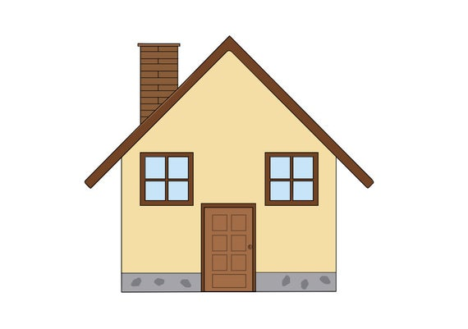

**Day to Day life:**

Research around both physical and mental health shows the importance of routines and boundaries for healthy development and positive wellbeing. With whole families now at home the majority of the time this is going to be more important than ever:

**Family rules:**

* Sit as a family and discuss how as a family you feel it is best to manage this current situation. Within this you might consider and discuss, in an age appropriate way, how you are going to manage things such as;
* Screen time
* How to agree on who’s turn it will be on TVs/Tablets/IPad/Games Consoles
* Who is responsible for making meals (Lunch/ Dinner) on which days
* Chores – with a lot of you in the house there is going to be a lot more to be done, divide this up into appropriate age categories so everyone knows their roles
* Snacks – to ensure food is kept at appropriate levels in the house and costs saved, boxes for each child with daily snack allowances have been useful for families. When the child eats all the snacks they have been allocated is their decision but It won’t be refilled till the next day, equally prevents continuous discussion about food in the house
* This is a generic list and families should consider what impacts their household most

**Routines:**

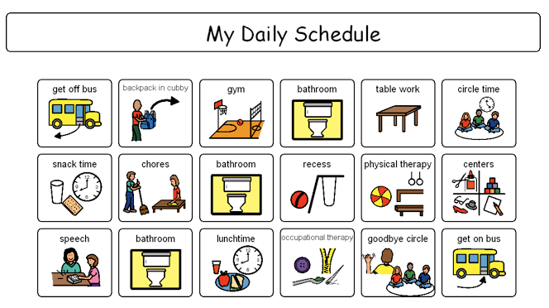

* Establish clear and visual routines for everyone to follow. This also includes home schooling.
* It is important to establish a pattern for your day e.g. what time everyone is expected to get up
* What activities are set in stone and where there is time for them to choose between activities?
* Compliance with this will increase where you can add an element of child led control. For example, make up a list/pictures/icons of things that you would like/ can be done in the day/week. Sit with your children and let them map out how they can fit things into the schedule around meal times.

**Home schooling**

* Many of you will be attempting home schooling; know that Staff Members are still working remotely to help you where there are difficulties. Equally, it is okay that the biggest thing your children might learn through this time frame is life skills and the practical application of subjects.



* For Example, Maths could be measuring ingredients out in cooking, Reading through the day etc.
* Where your children are older consider allocating time to sit with them to consider their work that is more prescriptive. You may not have the information/knowledge but the encouragement and dedicated time will go a long way in boosting confidence and engagement in the task.

Whilst this situation feels unusual and brings its challenges this is a really unique time to spend time with your children and young people. Try to find opportunities to engage in their play and interactions online. As long as you are clear about which boundaries and rules still stand and what you have all agreed on, don’t feel you need to become the teacher/enforcer.



**Managing Worries:**

We are living in uncertain times and children and young people are looking to us for the answers. Here are some key things to consider:

* Make sure the information they are accessing is age appropriate e.g. CBBC Newsround shows more child friendly information and a lot of news outlets at the moment are discussing best information to share with children
* It is okay to not have all the answers. All your children need is to feel safe and confident that adults around them are in control and the routines and boundaries you put in will ensure that.
* Focus on what is staying the same, rather than all the differences e.g. our house, our family, our day to day routine etc.
* Allow your child a book/box/a designated time to talk about their worry (Not bedtime!) if children come to you outside of that time remind them they can write down their worries and they will be discussed in the allocated time frame. So that the day is not taken over by worry and they know they can be contained by adults.



**Movement**

* Exercise and movement breaks are essential for sensory stimulation and wellbeing. When you are planning out your day ensure that allows for movements and exercise breaks every thirty minutes for neurodiverse children.
* You can do this in creative ways, whether it is just a run in the garden, set up a circuit loop for children to complete, add time limits and challenges to get them engaged.
* With older children walking pets, home workouts online, run or bike ride.
* It is vital for all of our mental health that we are getting fresh air where it is possible and sensible. Plan this into your routines!

**Better Communication:**



We are all adapting to living in a different way, and with everyone at home it is only typical that communication may become strained. We are all guilty of shouting up the stairs, listing instructions and becoming impatient and short tempered with each other as time goes on.

Children will model and respond to what they are presented with and, whilst we are living in this incredibly unusual time, all of our patience will wear thin. It is vital that for us, as adults, we model the communication style we would want. Throughout all of your communication it is important to consider your tone and body language. Consider if your tone of voice is calm but clear, requests given in this way lead to more compliance. Equally, ensure you have eye contact or direct face to face interaction where eye contact is not likely. This will remove any discussion and claim that the instruction was not heard and lead to more effective outcomes. Especially where it is likely your child or young person is likely to be upstairs with a head set on or on a tablet/ipad.

Here are some things to consider:

* Keep your instructions as clear and as simple as possible.
* For best compliance give a clear command and time frame you would like this to be done in. Adding this time frame removes any negotiation and debate as to when things need to be done. Within this, avoid a long string of commands, this only increases the likelihood of some or all of them not being adhered to.

*‘Put your toys away* ***now****’*

*‘You have five minutes, I will set a timer and then you will need to tidy up’*

* Consider what it is you want to gain
* Research shows us that children only process part of the sentence presented to them. This follows with being concise in your commands, in considering what it is you want them to hear.
* For example ‘Stop hitting your brother’, research shows us that children are more likely to just process ‘hitting your brother’. The goal is to keep their hands to themselves and therefore more helpful to ‘keep your hands to yourself’.
* Give choice and alternatives
* Children and young people are living through this very unusual time as well and currently have very little control over their days. Consider offering choice into your daily routines and activities where you know these outcomes are going to have very little impact to your overall goals for that day. This will increase compliance and boost independence and confidence skills.
* Use incentives
* Where giving instructions, particularly those that might be more difficult to get your child to engage with, consider use a ‘When-Then’ command.
* The key to these commands are that the ‘THEN’ part is an incentive

‘When you have made your bed, then we can put the TV on’

‘When you have eaten your lunch, then you can have you phone/tablet/ipad

**Rewards and Discipline**

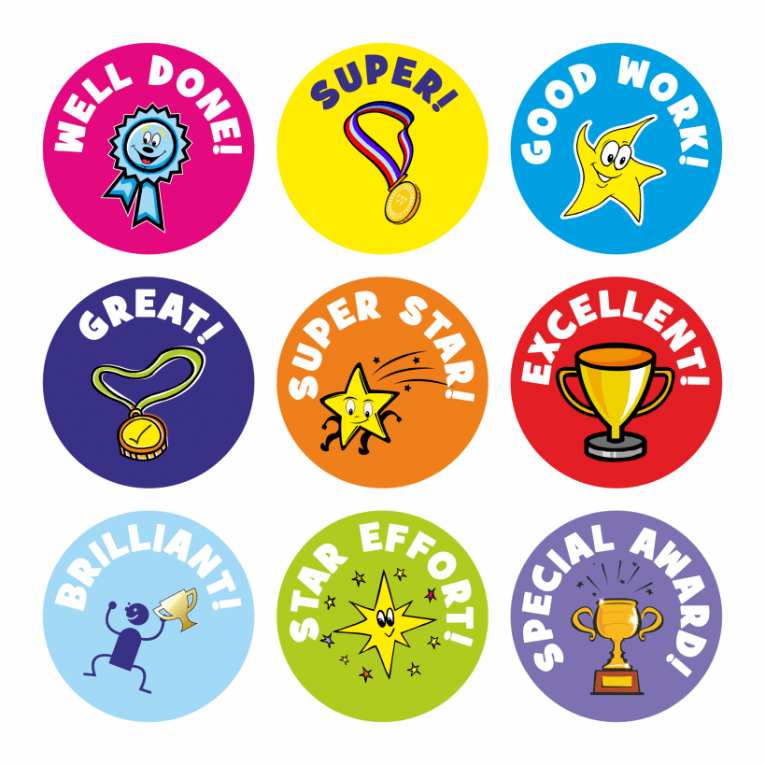

Finding the balance between enforcing boundaries and keeping the peace can be really challenging. Here are some ideas to remember:

* Focus on the Positive

As mentioned, children and young people often only process and take part of the information provided to them. With this in mind, focus on telling them what they are getting right rather than when they have got something wrong.

* Talk to your children about rewards and consequences. If children have been a part of the process for deciding what jobs/chores/roles will be allocated to family members, it is motivating to do them if they have been a part of the process for deciding on a reward.
* Star charts/Stickers/buttons – any visual can be used for children of any age (you will be surprised how quick teenagers are to compete) to incentivise them to get to comply
* The biggest guidance for this is that you don’t assign days to your chart/tracker; no child is going to feel motivated by seeing a big gap where they have failed to get sticker/reward for that day. This can be really detrimental to wellbeing.
* Focus on considering low cost/no cost rewards:
* Picking a film for film night
* Makeovers/manicures at home
* Extra time on gadgets

**Guidance for Rewards:**

* When giving a reward give plenty of praise at the time to label specifically what it was they have done so well
* Always give your rewards after the behaviour, not before - giving it before will reduce the motivation to comply
* With this mind, give the reward as soon after the behaviour as you can to reinforce the specific behaviour that is positive.
* Never take a reward away – even if you feel they don’t deserve it, they have done something to earn that reward in the first place so it is important their positive actions have been reinforced.
* Make sure your rewards/stars/stickers are for achievable behaviours and goals, especially at first, as this will motivate children to feel they can achieve.

**Guidance for Consequences:**

There are going to be times where your child or young person makes the wrong choice and consequences are necessary

* As previously mentioned discuss with your children and young people what feels like a reasonable consequence and what behaviour would be needed for e.g. swearing, not following instruction.
* Don’t go overboard with every negative action they could do, just go for the ones that you think you would not be able to ignore or would cause the biggest impact on a calm family life
* Consequences need to be proportional to the behaviour; we want children and young people to be able to redeem themselves and make amends, and this is difficult to do where they have lost privileges to every item they own. You want them to be able to give you the opportunity to demonstrate they won’t make that choice again.
* For behaviour that you would like to stop or prevent but don’t feel they need a specific consequence attached to focus on removing your attention.
* Children learn really early on that attention is their key to survival – they make a big noise and reaction and you attend to them, this is how they have survived infanthood.
* Choose to focus your attention on the behaviour you want!
* If it is siblings bickering telling tales on each other for example, explain clearly that when they are able to speak calmly and friendly you will listen. From this point you disengage from the conversation or remove physical presence and eye contact.
* Don’t remove yourself too far because as soon as you see compliance with what you have asked offer lots of praise and attention. Through this children will learn calm is the best way to get support on their issue.
* Consider the battles you really NEED to have during this time, where you can just focus on really effective ignoring and removal of attention. Again this is something you will need to explain to your children as part of your day to day family rules.
* Allow for natural consequences; if behaviour is going to warrant a natural consequence e.g. won’t wear a coat so will be cold, where this is safe, allow for children to experience some of this natural consequence to rectify their choices.

Technology – Gadgets



Technology is going to be a massive go to for many children and young people. It is worth highlighting in your family rules and conversations that the technology in your house is owned and paid for by parents/carers and therefore is their property.

It is a privilege to have free access to phones/iPad/tablets/TV, rather than a right.

Boundaries around this early on in this time frame will support beneficial relationships and positive times further down the line.

***Children and Young people should not be on Xbox/playstations/tablets/gaming devices for more than an hour in one sitting, therefore plan your day to reflect this.***